**UCI Data Boot Camp – Stefanie Huckleberry**

**Homework Unit 2**

**The VBA of Wall Street**

Screenshot – Year 2014

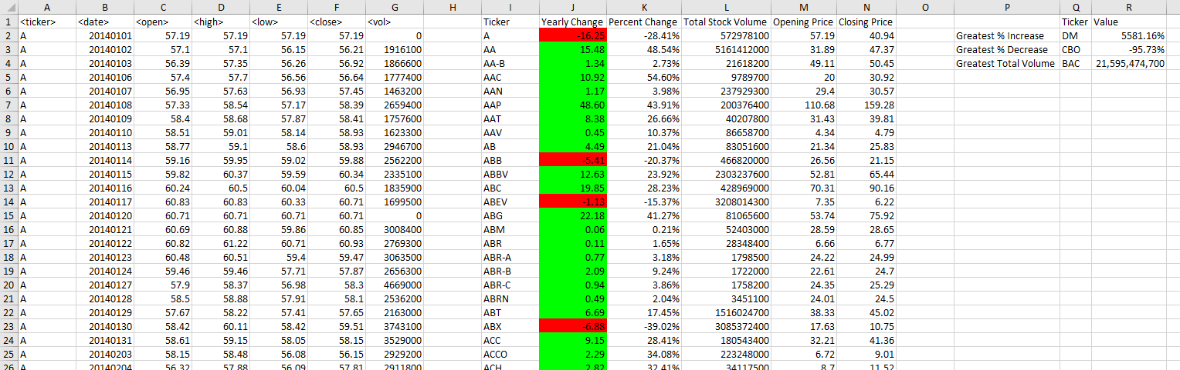

Screenshot – Year 2015

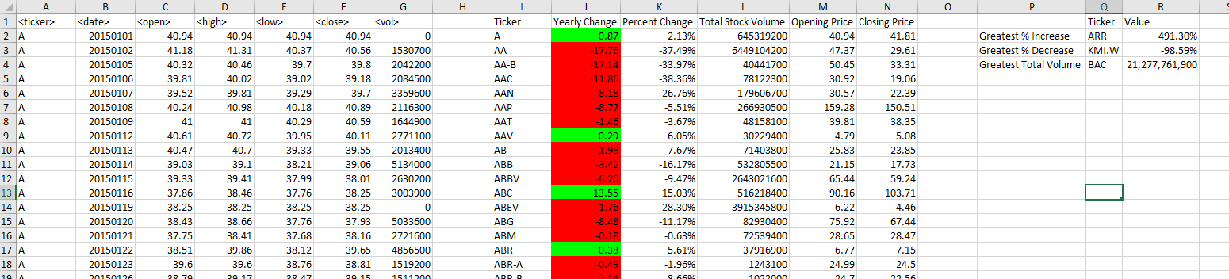

Screenshot – Year 2016

